Do the t-test on 2018 vs 2019 filter for good rain mean differences between Tucson and Flagstaff

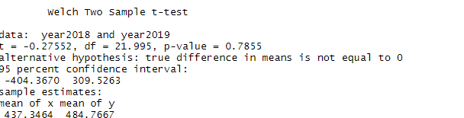

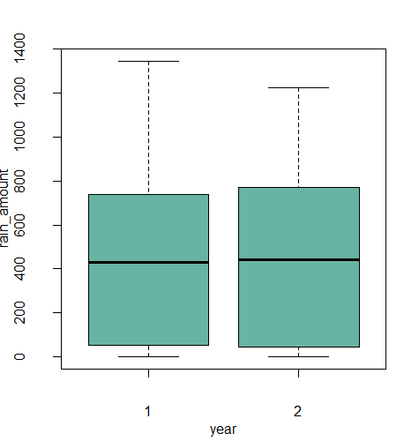

P value is more than 0.05, so they are not significantly different, which means they have similar pattern.

If we compare for specific months for the same year, they are significantly different.

Do the t-test on 2019-07/ 2019-08 in Tucson and flagstaff (filter for good)

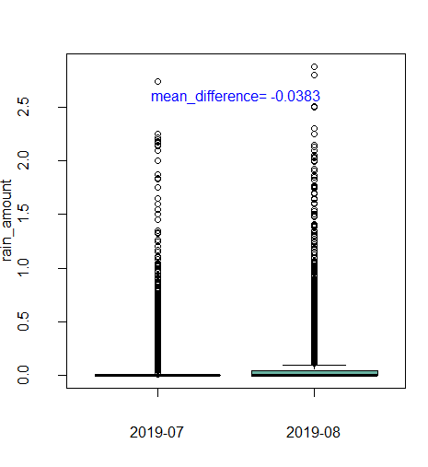

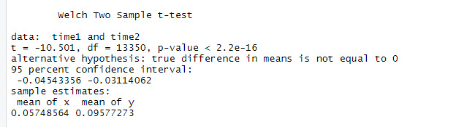

P value is less than 0.05, so the mean difference is significant

Flagstaff

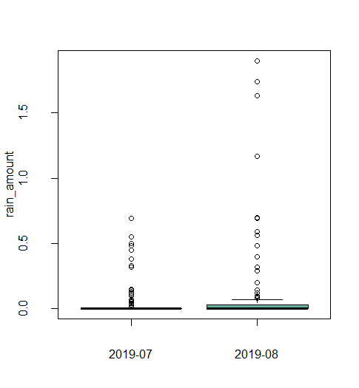

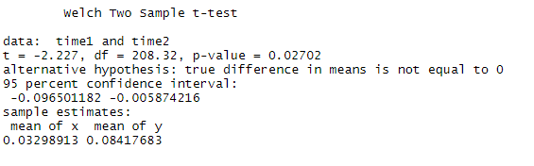

t-test showed the p value is less than 0.05, so the mean differences is significant.

.